The Decision Analysis Data Model

Gregory S. Parnell, gparnell@uark.edu
C. Robert Kenley, kenley@purdue.edu
Devon Clark, devclark@deloitte.com
Jared Smith, jarsmith@deloitte.com
Frank Salvatore, frank.salvatore@saic.com
Chiemeke Nwobodo, cnwobodo@deloitte.com
Sheena Davis, sheedavis@deloitte.com

Note to the Editor and Readers

This article is a summary of the following paper:

Parnell, G. S., Kenley, C. R., Clark, D., Smith, J. Salvatore, S. Chiemeke, N. Davis, S. “Decision Analysis Data Model for Digital Engineering Decision Management”, Systems, Artificial Intelligence and Digital Systems Engineering Special Issue, Systems 2025, 13(7), 596; https://doi.org/10.3390/systems13070596 (DADM)

Abstract
Decision management is the systems engineering life cycle process for making program/system decisions. The purpose of the decision management process is: “…to provide a structured, analytical framework for objectively identifying, characterizing and evaluating a set of alternatives for a decision at any point in the life cycle and select the most beneficial course of action. Systems engineers and systems analysts need to inform decisions in a digital engineering environment. This paper describes a Decision Analysis Data Model (DADM) developed in model-based systems engineering software to provide the process, methods, models, and data to support decision management. DADM can support digital engineering for waterfall, spiral, and agile development processes. This paper describes the decision management processes and provides the definition of the data elements. DADM is based on ISO/IEC/IEEE 15288, the INCOSE SE Handbook, the SE Body of Knowledge, the Data Management Body of Knowledge, systems engineering textbooks, and journal articles. The DADM was developed to establish a decision management process and data definitions that organizations and programs can tailor for their system life cycles and processes. The DADM can also be used to assess organizational processes and decision quality.

Keywords: digital engineering; decision management; data modeling; logical data modeling; model-based systems engineering; patterns; decision analysis

Introduction

To address the problem of the lack of a widely available and reusable model-based decision support system for systems engineers, the INCOSE Decision Analysis Working Group developed a Decision Analysis Data Model (DADM) in Model-Based Systems Engineering software that provides decision management guidance to support multi-factored decisions, such as design comparisons or trade studies, while leveraging a model-based environment to improve how those decisions are analyzed and communicated. This data model was developed using the decision management methodology defined in the INCOSE Systems Engineering Handbook (Walden et al. 2023), and defines the steps in the decision management process and identifies the data exchanged between those steps. The model can accelerate trade-off analyses, increase consistency, and support the documentation of decision outcomes in a digital model, enabling collaboration in a digital ecosystem in all life cycle stages.
The importance of this work is amplified by the INCOSE Systems Engineering Vision 2035 (Systems Engineering Vision 2025 2021), which outlines several challenges that must be realized to achieve the vision for the future state of systems engineering, including:
- Enable trusted collaboration and interactions through a digital ecosystem
- Provide analytical frameworks for managing the lifecycle of complex systems
- Widely adopt reuse practices

Review of Research on Decision Analysis Data in Systems Engineering
The need for systems engineers to obtain a comprehensive set of data to support system engineering decision making has been documented and reinforced across many decades.
- MIL-STD 499B (Department of Defense 1994, 31), published in 1994, describes a requirement for a decision data base, which is “a repository of information used and generated by the systems engineering process, at the appropriate level of detail …. The intent of the decision data base is that, when properly structured, it provides access to the technical information, decisions, and rationale that describe the current state of system development and its evolution.”
- The NASA Systems Engineering Handbook was initially published as NASA/SP-6105 in 1995. The 2007 revision describes a need to obtain a comprehensive set of data to support decision making while the initial 1995 publication does not. The most recent version of the NASA handbook (“6.8 Decision Analysis” 2019), published in 2019, states, “Once the technical team recommends an alternative to a NASA decision-maker (e.g., a NASA board, forum, or panel), all decision analysis information should be documented. The team should produce a report to document all major recommendations to serve as a backup to any presentation materials used…. The important characteristic of the report is the content, which fully documents the decision needed, assessments done, recommendations, and decision finally made.” In addition to prescribing the need to document decision analysis information, the NASA Systems Engineering Handbook prescribes that the process must be risk-informed, which may include both qualitative and quantitative techniques.
- The INCOSE Systems Engineering Handbook was initially published in 1997. Version 4 of the Handbook, published in 2015, was the first version to describe the need to obtain a comprehensive set of data to support decision making. The INCOSE Systems Engineering Handbook (Walden et al. 2023, 81), published in 2023, states “Decisions should be documented using digital engineering artifacts. Reports that include the analysis, decisions, and rationale are important for historical traceability and future decisions. The INCOSE Systems Engineering Handbook prescribes that the process must identify uncertainties and conduct probabilistic analysis.

Review of Research on Architectural Patterns, Reference Models, and Reference Architectures for Engineering Decisions

Bass, Clements, and Kazman (Bass et al. 2003, sec. 2.3) provide a framework for developing software that can be applied to develop a Decision Analysis Data Model to capture digital engineering artifacts that document decisions. They define three architectural structures:
- An architectural pattern is a description of element and relation types together with a set of constraints on how they may be used. A pattern can be thought of as a set of constraints on an architecture—on the element types and their patterns of interaction—and these constraints define a set or family of architectures that satisfy them. One of the most useful aspects of patterns is that they exhibit known quality attributes.
- A reference model is a division of functionality together with data flow between the pieces. A reference model is a standard decomposition of a known problem into parts that cooperatively solve the problem…. reference models are a characteristic of mature domains.
- A reference architecture is a reference model mapped into software elements (that cooperatively implement the functionality defined in the reference model) and the data flows between them. Whereas a reference model divides the functionality, a reference architecture is the mapping of that functionality onto a system decomposition.
There are many examples of architectural patterns, reference models, and reference architectures that have contributed to the advancement of digital engineering. See the DADM paper for a detailed review of this literature.

Systems Modeling Language (SysML) is a general-purpose modeling language for model-based systems engineering (MBSE) (“OMG Systems Modeling Language (OMG SysML) Version 1.7” 2024). It provides the capability to represent a system using the three UML diagram types and adding a fourth diagram type (Buede and Miller 2016):
- Structure, which includes Class – renamed to be Block, Package, and Parametric (new) diagrams and eliminates Component, Composite Structure, Deployment, and Object diagrams;
- Behavior, which includes Activity (modified), State Machine, and Use Case diagrams;
- Interaction, which includes Sequence diagrams and eliminate Collaboration – Communication, Interaction Overview, and Timing diagrams; and
- Requirements (new), which includes the Requirement (new) diagram.

Main Aim of DADM and Principal Conclusions

The main aim of DADM was to develop a model that:
- enables trusted collaboration and interactions through a digital ecosystem,
- be deployable and configurable for multiple decision domains
- provides an analytical framework for decision making across the lifecycle stages of complex systems,
- will be widely adopted,
- enables both traceability and reuse of analysis, decisions, and rationale for decisions,
- incorporates guidelines for identifying uncertainties and conducting probabilistic analysis and for documenting the rationale and results,
- provides information models built using composable knowledge and process models that emphasize learning in the presence of uncertainty, and
- can be tailored to agile development for DEVOPS
To meet these aims, the DADM was developed using composable SysML activity diagrams for process modeling and block definition diagrams for information modeling. The Magic System of Systems Architect was selected to implement the model, as it is widely designed for trusted digital collaboration, allows for traceability and reuse, allows capturing of guidelines and documentation, and can be tailored.

Methods

The methods used in developing DADM follow data modeling by the International Data Management Association (DAMA) and were informed by the INCOSE Agile Systems Engineering Life Cycle Model (ASELCM). Both DAMA and ASELCM shaped the approach described below.

Data Modeling
According to DAMA, Data Management is a wide-ranging set or activities, which includes the abilities to make consistent decisions about how to get strategic value using data (Data Management Association 2017). These activities are organized into the Data Management Framework, which identifies ten (10) categories of data management activities, which interact with an organization’s data governance to inform the data, information, and content lifecycle. These ten (10) data management activities begin with the definition of data architecture and design using data models. “Data modeling is the process of discovering, analyzing, and scoping data requirements, and then representing and communicating these data requirements in a precise form called the data model. This process is iterative and involves conceptual, logical, and physical models” (Data Management Association 2017).
The Decision Analysis Data Model mapped the inputs and outputs of the Decision Management processes defined in ISO/IEC/IEEE 15288 (ISO - International Organization for Standardization 2023), the INCOSE Systems Engineering Handbook (Walden et al. 2023), and the SEBoK (SEBoK Editorial Board 2024) to identify the high-level ‘decision concepts’ needed to execute the high-level Decision Management process. From there, the conceptual data model was decomposed and traced to an implementation-agnostic logical model, which defines data-driven processes and the data needs connecting them. Finally, implementation-specific physical data models would be tailored from the logical data model on a project-by-project basis.

Conceptual Data Model (CDM)
“A conceptual data model captures the high-level data requirements as a collection of related concepts. It contains only the basic and critical business entities within a given realm and functions.” (Data Management Association 2017) In this regard, the conceptual DADM provides an executive-friendly definition of the key concepts that apply to the business needs for their decision making. For example, the concept of a decision should include definitions of the decision itself, including the decision-maker(s), the alternatives being considered, and the values against which those alternatives will be evaluated. A summary of the DADM’s conceptual model is provided in Section 3.1.

Logical Data Model (LDM)
A CDM is too high level to be implemented. The CDM defines needs without mapping those needs to data solutions. “A logical data model (LDM) captures the detailed data requirements within the scope of the CDM.” (Data Management Association 2017) For example, whereas our CDM defines the decision concept as including a decision-maker, a set of alternatives, and a set of values, our LDM maps those to specific data points, to include a decision authority, courses of action, and objectives. As the LDM was further refined, those data needs also included properties such as data attributes and domains, and the structure of data began to take shape without discussing additional properties of the data structure, such as format and validation rules, which are reserved for the physical data model. A summary of the DADM’s logical data model is captured in Section 3.2.

Physical Data Model
“Logical data models require modifications and adaptations in order to have the resulting design perform well within storage applications.” (Data Management Association 2017) Therefore, the implementation specifics for any given solutions are defined in the Physical Data Model for that individual system. Note, the purpose of the Decision Analysis Data Model is to provide a reference for implementation for systems engineers and developers. Therefore, the DADM does not include a Physical Data Model.

Agile Systems Engineering Life Cycle Model
The INCOSE Agile Systems Engineering Life Cycle Model (ASELCM) has three major systems (Figure 1). The INCOSE ASELCM is a model of learning patterns that describes how systems improve through three interconnected levels: 1) The Target System; 2) the Lifecycle Domain System; and 3) The System of Innovation. System 1 of the ASELCM represents an engineered system of intertest (and its components) about which development and operations decisions are being made. Note that many different instances of Systems 1 may be present over time. Examples include aircraft, automobiles, telephones, satellites, software systems, data centers, and health care delivery systems. System 2 is the life cycle domain system, which is the system within which different instantiations of System 1 will exist during their life cycle. This includes any system that directly manages the life cycle of an instance of a target system during its development, production, integration, maintenance, and operations. If System 1 is managed as a program over its life cycle, then Systems 2 can be thought of as a program office responsible for the life cycle stages of System 1 (and the program’s associated processes). Different instances of System 2 can occur, e.g., one instance could be a program office responsible for development, production, and integration; and another instance could be a program office responsible for maintenance and operations. System 3 is the system of innovation that includes System 1 and System 2, and that is additionally responsible for managing the life cycles of instances of any System 2. System 3 develops, deploys, and manages System 2 work processes and evaluates them for improvements. System 3 can be thought of as the enterprise innovation system, e.g., an organization that develops, produces, and integrates many diverse kinds of systems, or a user that operates, integrates, and maintains many different systems. The System of Innovation produces better lifecycle processes…and better lifecycle processes get implemented to produce better target systems.

Figure 1. Top-Level Agile System Engineering Life Cycle Model (Schindel and Dove 2016)

Figure 2 shows how DADM can be embedded in the ASELCM to support digital engineering. The System 3 enterprise-level system of innovation can deploy an instance of the DADM logical model to a System 2 program management entity within the enterprise. The System 2 life cycle manager is responsible for using the logical process model to develop a physical model of the DADM artifacts.

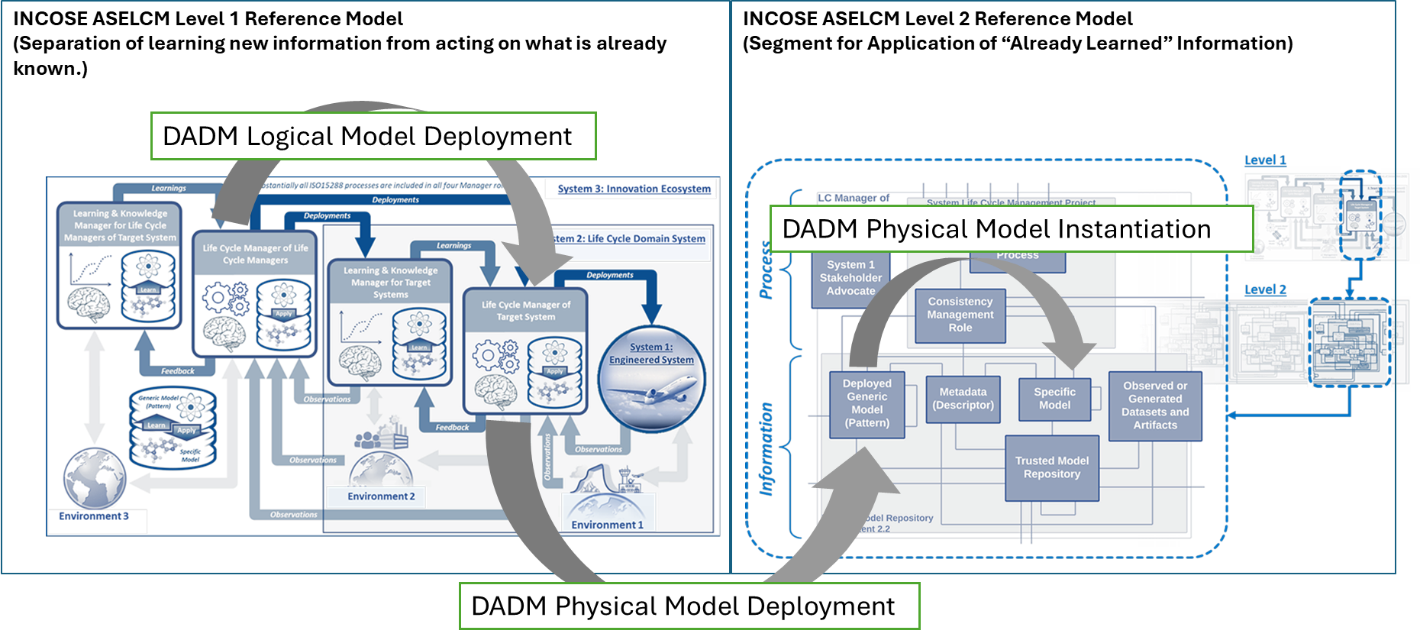
Figure 2. DADM is a Deployed Generic Model (Pattern) to be Applied for Making Decisions about an Engineered System (Pinon Fischer et al. 2022)

Data Model Validation
From a design perspective, data models are validated by mapping inputs and outputs through an organization’s business processes, by assuring traceability across the conceptual, logical, and physical models, by justifying the models’ activities and data conform to best practices that are documented in the literature, and by independent review of the model by subject matter experts. The business process for the DADM are the Decision Management processes defined in ISO/IEC/IEEE 15288 (ISO - International Organization for Standardization 2023), the INCOSE Systems Engineering Handbook (Walden et al. 2023), and the SEBoK (SEBoK Editorial Board 2024). Traceability for the DADM is achieved by decomposing the conceptual data model activities and data in a traceable manner to the logical model. Validating that the models’ activities and data conform to best practices is done by following relevant standards, bodies of knowledge, systems engineering textbooks, and journal articles in developing the models. Conformance to best practices is demonstrated in this article by the extensive citations in the Section 3 and Appendix A. DADM has been reviewed by the INCOSE Impactful Products Committee and approved for release in the INCOSE Systems Engineering Laboratory(“SYSTEM ENGINEERING LABORATORY” 2025).
Validation of the feasibility and effectiveness of the DADM model will be achieved by seeking government and industry users who will deploy the DADM MBSE implementation and provide feedback on its use in their organizations.

Results – The Decision Analysis Data Model.
This section describes the DADM conceptual data model for each of the ten steps in the Decision Management Process and provides illustrative data artifacts for each step. For each step, we describe the purpose and some of the system engineering methods used to create decision management data. We also provide tailoring and reuse guidance for each step. The Logical Process Model is described by Parnell, et al. (Parnell et al. 2025) and illustrates key concepts for each of the ten steps. For each of the ten steps, they have Activity Diagrams that provide the activity and information flow to develop the decision data elements and a Block Definition Diagram that shows the relationships between the data elements. In addition, they illustrate the major data artifacts, provide definitions of all the decision data elements, and provide references to the systems engineering and decision analysis literature.
The foundation of DADM can be summarized via a data flow model, Figure 3, that identifies the sequence conceptual management steps that are executed sequentially in the numerical order shown without skipping any of the steps. The data flow model shows the inputs to the first step, the outputs from the final step, has arrows to indicate the general flow of data between the steps. The figure lists the illustrative data artifacts generated for each step in the process. Each step describes an important activity and includes data artifacts used to inform the decision management team. More detailed discussion of the data and conceptual management steps will be provided in the subsequent sections. The data flow and the data artifacts can be reused with appropriate modifications in subsequent system life cycle stages.

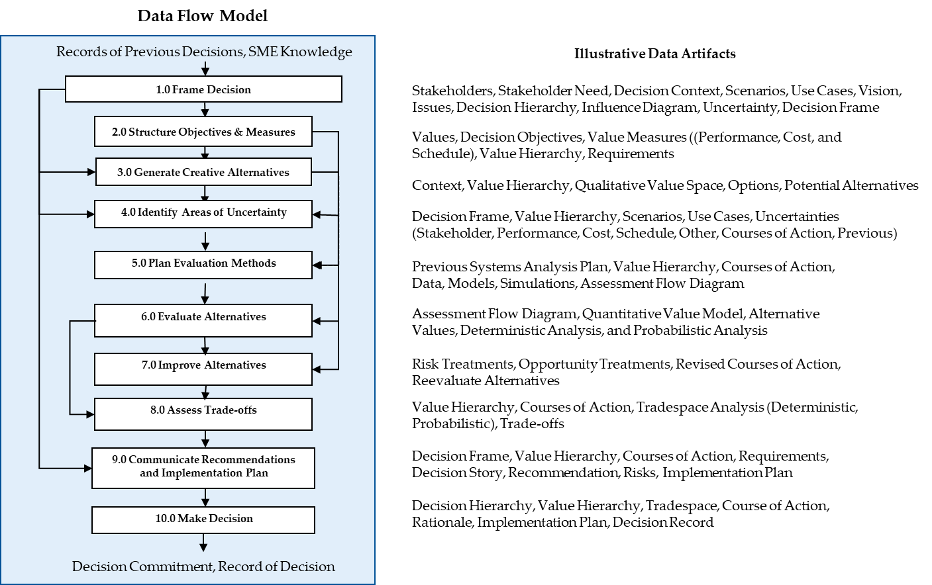
Figure 3. DADM Data Flow Model and Illustrative Data Artifacts. Some artifacts are updated in subsequent steps.

Table 2 provides the name of each of the ten steps, the purpose of each step, and common methods used in other systems engineering decision models and the system engineering literature.

Table 2. DADM purpose and alternative methods for each DADM Conceptual Model Process step.
Step | Purpose | Common Methods
1.0 Frame Decision | Identify the purpose and scope of the decision in the context of the system life cycle. | Problem Definition, Opportunity Definition, Influence Diagram, Stakeholder Analysis, Use Cases, Scenarios, Systems Thinking
2.0 Structure Objectives and Measures | Identify the decision objectives and the measures that will be used to assess achievement of the objectives before we develop the alternatives. | Value Hierarchy, Objectives Hierarchy, Value Tree, Requirements Analysis
3.0 Generate Creative Alternatives | Develop creative alternatives that span the decision space of feasible alternatives including innovative technologies and new production, service, and delivery processes. | Zwicky’s Morphological Box, Structured Creativity Techniques, Optimization, Set-Based Design, Pugh Method, TRIZ
4.0 Identify Areas of Uncertainty | Identify uncertainties to understand potential risks and opportunities and allow decision-makers to evaluate choices more accurately. | Risk and Opportunity Analysis, Influence Diagram, Scenario Analysis
5.0 Plan Evaluation Methods | Plan evaluation methods to identify the data, the models, simulations, process flow, resources and time required to perform an alternative assessments that biases and enhances the reliability of the analysis. | Assessment Flow Diagram, Systems Engineering Management Plan
6.0 Evaluate Alternatives | Implement the alternative evaluation plan to assess the performance, value, cost, and schedule of the alternatives. | Deterministic Analysis, Probabilistic Analysis, Portfolio Analysis, Benefit Cost Analysis, Modeling, Simulation, and Analysis, Optimization, Systems Analysis, Risk Analysis, Mission Analysis, Life Cycle Cost Analysis, Scheduling
7.0 Improve Alternatives | Use the evaluation information to improve the alternatives by increasing value and reducing risk. | Value-Focused Thinking, Risk Analysis, Risk Management, Systems Thinking, Systems Analysis, Optimization
8.0 Assess Trade-offs | Assess the value trade-offs including performance, value, cost, and schedule trade-offs. | Tradespace, Trade-off Analysis, Systems Analysis, Pareto Analysis, Cost as an Independent Variable
9.0 Communicate Recommendations and Implementation Plan | Communicate the trade-offs, recommendation(s), and implementation plan to the system decision maker (s) for their decision. | System Decision, Solution Implementation, Implementation Schedule
10. Make the Decision | Make the decision and document the rationale. | Decision Record

3.2. Logical Data Modeling

For each of the 10 process steps the DADM paper provides a logical process model and a logical data model: Block Definition Diagram. See the paper for the other 9 steps. The DADM paper also provides a list of the definitions of all the terms used in DADM in Appendix A.

Step 1: Frame Decision
Spetzler, Winter, and Meyer define the decision frame as a collection of artifacts that answer the question: “What problem (or opportunity) are we addressing?” That is comprised of three components: (1) our purpose in making the decision; (2) the scope, what will be included and excluded; and (3) our perspective including, our point of view, how we want to approach the decision, what conversations will be needed, and with whom. (Spetzler et al. 2016, 13). Figure 4 uses an activity diagram to depict the logical process for defining a decision frame.
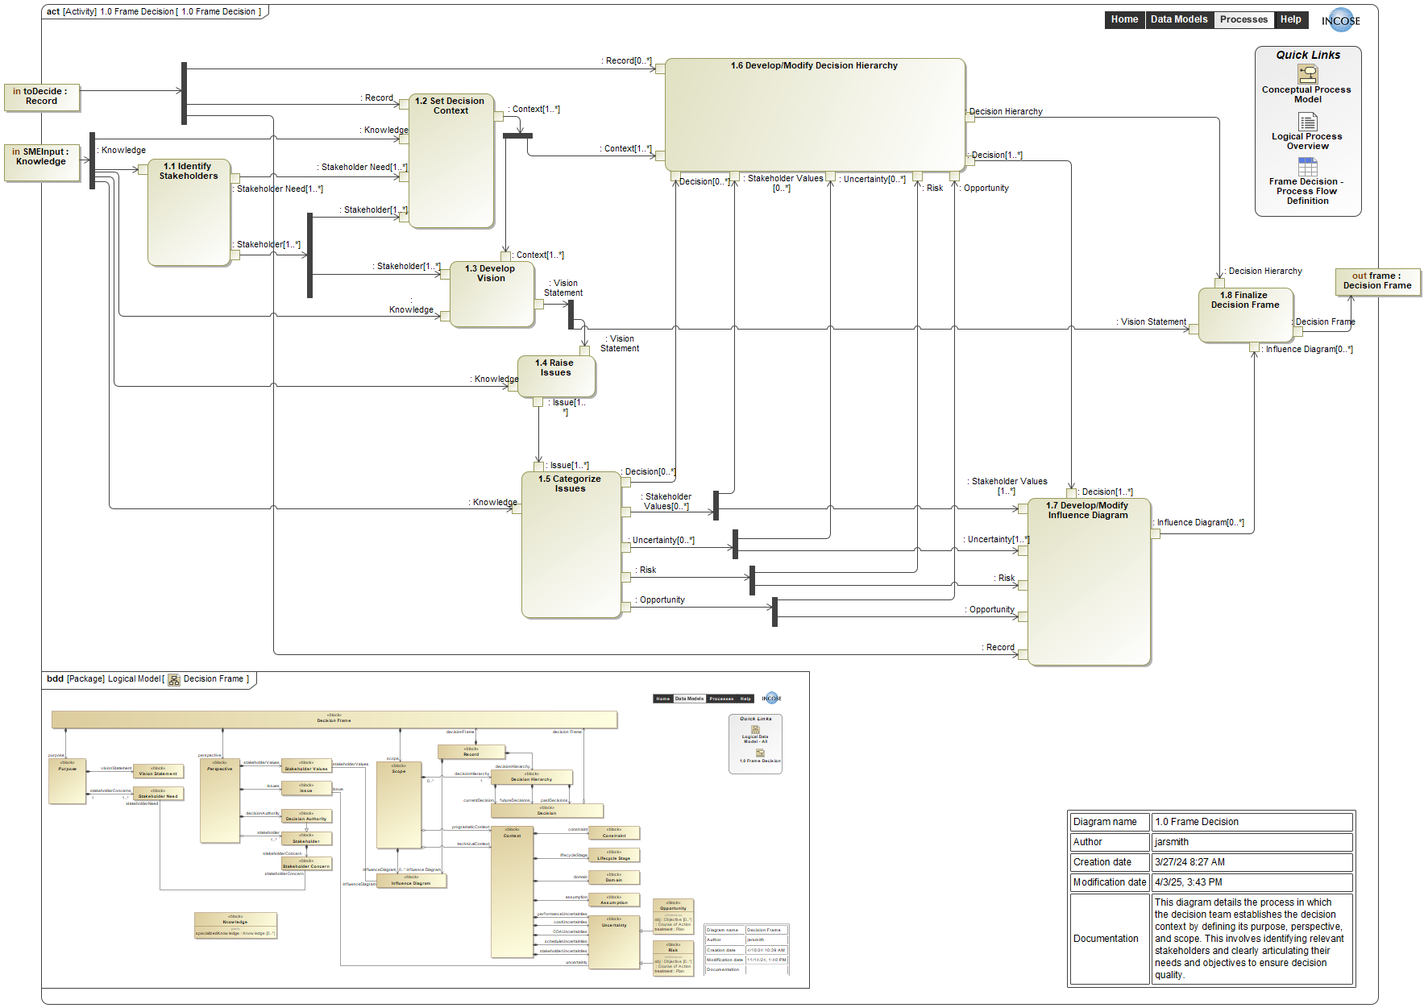
Figure 4. Logical Process Model: Activity Diagram for Step 1, Frame Decision
The Frame Decision process is described by the 8 steps (1.1 to 1.8) shown in Figure 4. The process uses inputs from past decisions and from subject matter experts (SME’s). The process ends with a well-formed decision frame. The first step is to 1.1 identify the stakeholders that need to be included in the decision at hand. Every decision is potentially unique and may require different stakeholders. By using interviews, surveys and facilitated brainstorming sessions, the stakeholders’ needs will be captured to help 1.2 set the decision context and 1.3 develop the vision that will define the decision purpose and help keep the decision analysis efforts focused. In addition to the context and vision it is also important to 1.4 raise issues that may have been identified by the stakeholders, SME knowledge or past decisions and 1.5 categorize issues. The issues, stakeholder needs, context, vision, are used to help identify uncertainty, risk, and or opportunity. This information is used to 1.6 develop and modify a decision hierarchy. It is also used to 1.7 develop/modify influence diagrams. The context and vision for the decision are combined with the decision hierarchy and influence diagram resulting in the 1.8 decision frame.

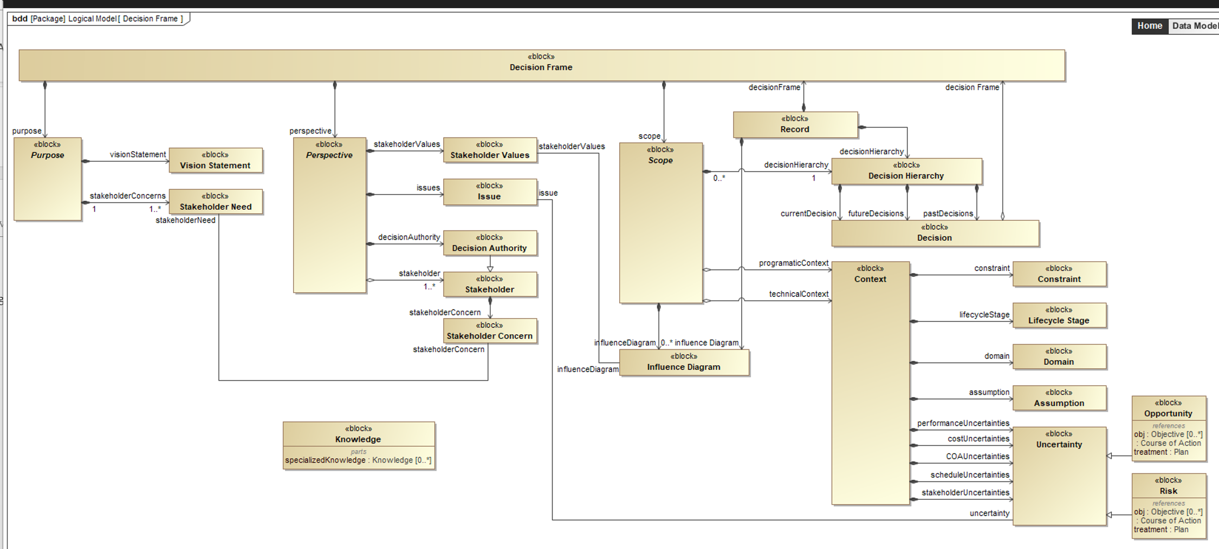
Figure 5. Logical Data Model: Block Definition Diagram for Step 1, Frame Decision
Table 3 provides important guidance for reuse and tailoring for each step to the decision management process for your organization (System 2) and your system (System 3). The quality of each step should be validated with the decision-makers(s) and key stakeholders. We do not recommend skipping any step, but your organization may choose to combine steps. For example, the Systems Decision Process (Driscoll et al. 2022) uses Problem Definition (Steps 1 and 2), Solution Design (Steps 3 and 7), Decision Making (Steps 5 and 8) and Solution Implementation (Steps 9 and 10).

Table 3. DADM Tailoring and Reuse Guidance
Step | Tailoring and Reuse Guidance | Impact of Not Doing
1.0 Frame Decision | The decision(s) should be clearly identified in each life cycle stage or decision point. It is usually helpful to begin with the decisions made in the previous life cycle stage and identify revised and additional decisions. | The system may be developed for the wrong problem, not take advantage important opportunities, or not address stakeholder concerns.
2.0 Structure Objectives and Measures | The value hierarchy should be updated based on the current information in each stage. New objectives and measures may be needed based on latest information about the problem and the system. | The alternative design and evaluation will not focus on the decisionmaker and stakeholder objectives. This may lead to rework and schedule delays.
3.0 Generate Creative Alternatives | It is important to generate creative alternatives that span the decision space. The alternatives may include previous alternatives and new alternatives to increase value and/or reduce risk. | The decision can only be as good as the best alternative. Poor alternatives lead to poor decisions.
4.0 Identify Areas of Uncertainty | The sources of uncertainty will vary in each life cycle stage. Some uncertainties will be resolved, and new risks and opportunities will be identified. | Systems are designed for years and sometimes decades. There are many uncertainties. If they are not considered, rework will be required.
5.0 Plan Evaluation Methods | As better information becomes available on the system alternatives in the life cycle, higher fidelity evaluation methods can be used. | The lack of an alternative evaluation plan to obtain appropriate fidelity evaluation methods for the life cycle stage can lead to rework and schedule delays.
6.0 Evaluate Alternatives | The alternative evaluations should be updated based on new alternatives, new uncertainties, improved evaluation methods, and updated data. | Poor evaluation can lead to rework, schedule delays, or system cancelation.
7.0 Improve Alternatives | It is important to improve the alternatives using the information from the alternative evaluations. Value gaps can be identified and filled. Risk can be mitigated, and new opportunities can be addressed. | Not improving the alternatives before the decision can result in less value, more risk, and rework.
8.0 Assess Trade-offs | Once the alternatives have been improved, the next step is to update the value, performance, cost, and schedule trade-offs. The impacts on other systems and stakeholders should also be considered. | Unless there is one alternative that dominates all the others, there will be trade-offs between the alternatives that decision makers may not consider.
9.0 Communicate Recommendations and Implementation | The systems engineers (system analysts) should communicate the trade-offs, recommendation(s), and implementation plan to the system decision maker (s) for their decision using the organization’s recommended decision process. | Without clear and concise communication of the recommendations, the best decision may not be made or be actionable.
10.0 Make the Decision | Record the decision and rationale using organizational procedures. | Without records, we lose traceability of past decisions and rationale.

Discussion
The DADM can be used in the Concept Stage and reused to inform Life Cycle Decisions throughout the system life cycle. In Table 4, we use the Generic Life Cycle (15288-2023 - ISO/IEC/IEEE International Standard - Systems and Software Engineering--System Life Cycle Processes 2023; Walden et al. 2023) to provide decisions opportunities to improve the system value that are commonly encountered throughout a system’s life cycle. Many of these decisions would benefit from a DADM that integrates the data produced by performance, value, cost, and schedule models that are meaningful to the decision makers and stakeholders. The table also lists the types of data that would be available in DADM for each life cycle stages.

Table 4. Illustrative decisions and data availability throughout the System Life Cycle (Adapted from(Walden et al. 2023))
Life Cycle Stage | Illustrative Decisions | Data Availability
Concept Stage | Assess Technology Opportunity / Initial Business Case  - Of all the potential system concepts or capabilities that could incorporate the emerging technology of interest, do any offer a potentially compelling and achievable market opportunity?  - Which should be pursued, when, and in what order?  Inform, Generate, and Refine a Concept  - What requirements should be included?  - What needs to be accomplished and what can be traded away to achieve it within anticipated cost and schedule constraints?  - How should requirements be expressed such that they are focused, yet flexible?  - How can the set of requirements be demonstrated to be sufficiently compelling while at the same time achievable within anticipated cost & schedule constraints? | Descriptive data on existing systems.  Predictive data using low fidelity models for new concepts  Predictive data on new technologies and concepts using low fidelity models
Create Solution Class Alternatives and Select Preferred COA
- After considering the system level consequences of the sum of solution class alternatives across the full set of stakeholder values (to include cost and schedule), which solution class alternative should be pursued?
Development Stage | Select/Define System Elements  - After considering the system-level consequences of the system element design choices across the full set of stakeholder values (to include cost and schedule), which system-element alternatives should be pursued?  - Make or buy decisions for system, subsystems, and elements | Descriptive data on existing system elements  Predictive data on new system elements and the system using high fidelity models  Development test data in later parts of the stage
Select/Design Verification and Validation Methods
- Is prototyping warranted?
- What verification and validation methods should be performed (test, demonstration, analysis/simulation, inspection)?
- What are the verification and validation plans?
Production Stage | Develop Production Plans  - What is the target production rate?  - To what extent will low-rate initial production be used?  - What is the ramp-up plan?  - What production processes will be used?  - Is the system still affordable? | Initial operational test and evaluation data  Descriptive production quality data
Utilization and Support Stages | Utilization decisions  - What are the best operations concepts for the resources available?  Support decisions  - What is the maintenance strategy?  - What is the logistics concept?  - What is the preventive-maintenance plan?  - What is the corrective-maintenance plan?  - What is the spare-parts plan?  - Is the system still affordable? | Operational and logistics descriptive data  Predictive data using high fidelity operational and logistics models
Retirement Stage | Retirement Plan  - When is it time to retire the system?  - How will disposal of the system materials be accomplished? | Operational and logistics descriptive data  Predictive data using high fidelity operational and logistics models

Looking ahead, the DADM has a clear path for incremental development through a series of targeted future activities. The next step is the development of example implementations and case studies. By piloting DADM in real-world contexts—such as system acquisitions, technology selection, or lifecycle planning—we intend to demonstrate its practical value, collect lessons learned, and gather specific feedback to further refine the model. These case studies will help build a stronger evidence base for DADM’s utility and support broader adoption by offering concrete examples and guidance for potential users.
We will continue iterating on the model alongside this effort, aiming for the release of DADM v2.0 in late 2025. This version will include a physical data model, shaped by insights from pilot use cases, and will serve as a detailed reference for organizations evaluating DADM. Maintaining this feedback-driven refinement process will help ensure the model continues to meet the needs of the systems engineering community.
Technical integration is another near-term opportunity. Aligning DADM with SysML v2 and BPMN will promote interoperability with contemporary MBSE tools and strengthen traceability from requirements through decision analytics. Another active area of exploration is the incorporation of artificial intelligence (AI)—especially Large Language Models (LLMs)—to assist with data ingestion, recommendation generation, and automation of alternative evaluation or risk assessment. A longer-term goal is to enable auditable, AI-enabled decision support by capturing rationale and potential bias, thereby supporting regulatory and ethical compliance.
In parallel, pursuing formal standardization remains important. As we validate and improve DADM through pilot projects, workshops, and collaboration with industry, steps toward a standards designation will encourage wider, more consistent adoption across organizations. Through these targeted activities, DADM will continue to advance toward enabling data-driven, transparent, and auditable decision-making in MBSE and digital engineering environments.

About the Authors
Gregory S. Parnell is a Professor of Practice in the Department of Industrial Engineering at the University of Arkansas and Director, System Design and Analytics Laboratory (SyDL), and Director of the M.S. in Operations Management and M.S. In Engineering Management programs. He was lead editor of Decision Making for Systems Engineering and Management, (2nd Ed, 2011), lead author of the Handbook of Decision Analysis, Wiley Operations Research/ Management Science Series (2013), and editor of Trade-off Analytics: Creating and Exploring the System Tradespace (2017). He previously taught at the West Point, the U.S. Air Force Academy, the Virginia Commonwealth University, and the Air Force Institute of Technology. He has a Ph.D. from Stanford University. He is a retired Air Force Colonel.
C. Robert Kenley is a Professor of Engineering Practice at Purdue’s Edwardson School of Industrial Engineering, where has been developing courses and curricula to support the educational objectives of the Purdue Systems Collaboratory. He has over 30 years’ experience in industry, academia, and government as a practitioner, consultant, and researcher in systems engineering. He has published papers on systems requirements, technology readiness assessment and forecasting, Bayes nets, applied meteorology, the impacts of nuclear power plants on employment, model-based systems engineering, and agent-based modeling for systems of systems. He is an expert system engineering professional (ESEP), and a Fellow of INCOSE. He holds an SB in Management from the Massachusetts Institute of Technology, an MS in Statistics from Purdue, and an MS and a PhD in Engineering-Economic Systems from Stanford.
Devon Clark is a leader in Systems Engineering, Integration, and Test (SEI&T), Digital Engineering, and Decision Analysis with over 25 years combined experience as a contractor and civilian working in (or for) Defense, Security, and Justice government agencies. Devon is a leader in Deloitte’s Mission Solutions Community of Practice (CoP), a member of the INCOSE Corporate Advisory Board, and co-chair of the Decision Analysis Working Group. Devon specializes in Digital Transformation, Model-Based Systems Engineering (MBSE), and Decision Analysis. He holds a Bachelors degree in Physics from Georgia Tech and a Masters degree in Systems Engineering from the Naval Postgraduate School.
Jared Smith is a Manager at Deloitte Consulting, specializing in digital engineering for defense programs. He serves as Co-Chair of INCOSE’s Decision Analysis Working. Prior to joining Deloitte, he supported multiple defense manufacturers as a Model-Based Systems Engineer and trainer. His expertise includes digital development environments, enterprise architectures, data-driven decision analysis, and generative AI applications. He holds a BS in Industrial and Systems Engineering from the University of Alabama in Huntsville and is a certified Six Sigma Black Belt.
Frank Salvatore received his Bachelor of Science degree (BS) in Electrical Engineering (EE) from the New Jersey Institute of Technology (NJIT) and his Master of Science (MS) in Computer Science (CS) from American University (AU.) He is a Senior Systems Engineer and Technical Fellow in the area of Model Based Systems Engineering (MBSE) for SAIC. He has been a consultant for SAIC since 1999 providing various degrees of Systems Engineering support to the U.S. Army, the Office of the Under Secretary of Defense, and the Navy. He also worked for the U.S. Army and ITT industries providing a variety of systems engineering support for the development of Army Smart Munitions, GPS navigation payload, and a Software Programmable Radio. He is an Expert Systems Engineering Professional (ESEP) an Object Management Group (OMG) Certified Systems Modeling Professional (OCSMP), and Six Sigma Green Belt. He is also a member of the International Council on Systems Engineering (INCOSE,) is the Past President of the Liberty Chapter, the Chair of the Decision Analysis Working Group, and the Co-Chair of Digital Engineering Information Exchange Working Group (DEIX WG.)
Chiemeke Nwobodo is a Senior Consultant at Deloitte with experience in the IT, Cybersecurity, and Systems Engineering industry serving several clients. He works to solves complex problems within organizations using his knowledge of IT Asset Management, Enterprise Architecture, and Model-Based Systems Engineering. He is constantly expanding his expertise by obtaining certifications such as AWS, ServiceNow, TOGAF, Sec+ which assist him in critically considers different approaches when tackling new challenges. With the passion he has for MBSE, he has become deeply involved with the model development of the Decision Analysis Data Model in pursuit of achieving the INCOSE Vision 2035. He holds a B.SC in Information Sciences and Technology from the Pennsylvania State University.
Sheena Davis is a Consultant at Deloitte. She has utilized her healthcare and technological knowledge to providing case management, quality assurance, and IT support for the Department of Veteran Affairs. Additionally, she is an AWS Certified Cloud Practitioner and is working to obtain to more certifications to expand her knowledge and skills. She holds a B.S. in Computer Science from Old Dominion University, a B.A. in Psychology from The University of North Carolina at Chapel Hill, and an Occupational Therapy Doctorate from Virginia Commonwealth University.

References
“6.8 Decision Analysis.” 2019. In Systems Engineering Handbook. NASA. https://www.nasa.gov/reference/6-8-decision-analysis/.
15288-2023 - ISO/IEC/IEEE International Standard - Systems and Software Engineering--System Life Cycle Processes. 2023. IEEE.
Bass, Len., Paul Clements, and Rick. Kazman. 2003. Software Architecture in Practice. 2nd ed. SEI Series in Software Engineering. Addison-Wesley.
Buede, Dennis M, and William D. Miller. 2016. The Engineering Design of Systems: Models and Methods. 3rd ed. Wiley. http://ebookcentral.proquest.com/lib/purdue/detail.action?docID=4391537.
Data Management Association. 2017. Data Management Body of Knowledge (DMBOK). Second edition. 1 online resource (626 pages). Technics Publications. WorldCat. https://proquest.safaribooksonline.com/9781634622479.
Department of Defense. 1994. Systems Engineering. MIL-STD-499B. Version Draft. Washington, DC, May 6.
Driscoll, Patrick J., Gregory S. Parnell, and Dale L. Henderson. 2022. Decision Making in Systems Engineering and Management (3rd Edition). John Wiley & Sons. https://app.knovel.com/hotlink/pdf/id:kt013XX8S1/decision-making-in-systems/stakeholders-vested-interests.
ISO - International Organization for Standardization. 2023. Systems and Software Engineering--System Life Cycle Processes. ISO/IEC/IEEE 15288:2023. International Organization for Standardization.
“OMG Systems Modeling Language (OMG SysML) Version 1.7.” 2024. June. https://www.omg.org/spec/SysML/1.7/.
Parnell, Gregory S., C. Robert Kenley, Devon Clark, et al. 2025. “Decision Analysis Data Model for Digital Engineering Decision Management.” Systems 13 (7). https://doi.org/10.3390/systems13070596.
Pinon Fischer, Olivia J., John F. Matlik, William D. Schindel, et al. 2022. “Digital Twin: Reference Model, Realizations, and Recommendations.” INSIGHT 25 (1): 50–55. https://doi.org/10.1002/inst.12373.
Schindel, Bill, and Rick Dove. 2016. “Introduction to the Agile Systems Engineering Life Cycle MBSE Pattern.” INCOSE International Symposium 26 (1): 725–42. https://doi.org/10.1002/j.2334-5837.2016.00189.x.
SEBoK Editorial Board. 2024. The Guide to the Systems Engineering Body of Knowledge (SEBoK). V 2.11. The Trustees of the Stevens Institute of Technology. www.sebokwiki.org.
Spetzler, Carl S., Hannah Winter, and Jennifer Meyer. 2016. Decision Quality : Value Creation from Better Business Decisions. Wiley.
“SYSTEM ENGINEERING LABORATORY.” 2025. June. https://www.incose.org/learn/se-laboratory.
Systems Engineering Vision 2025. 2021. International Council on Systems Engineering. https://www.incose.org/publications/se-vision-2035.
Walden, David D., Thomas M. Shortell, Garry J. Roedler, et al., eds. 2023. Systems Engineering Handbook: A Guide for System Life Cycle Processes and Activities. 5th ed. INCOSE Systems Engineering Handbook. Wiley.

